1. **To Be or not to Be**

Create a program asking the user “Who is the author of Romeo & Juliet?”.

If they enter “Shakespeare”, then print the message “Correct”

If they enter any other answer, print “Incorrect”

1. **Casino**

If they are 21 or older, print “Welcome to Cassie’s Casino”

If they are younger than 21, print “Sorry, you cannot enter”

In this beginners exercise, you do not need to set up a upper and lower input limits

1. **Are you Positive?**

Ask user to enter a number and tell them if the number is positive or negative

1. **Pass or Fail**

Create a program that asks the user what they scored on a grade.

|  |  |
| --- | --- |
| **Score** | **Grade** |
| 90 or higher | A |
| 80 to 89 | B |
| 70 to 79 | C |
| 60 to 69 | D |
| 0 to 60 | F |
| < 0 or > 100 | error |

1. **Try except**

Create a program that converts hours to minutes

Ensure that the program does not crash when user enters a string

1. Create a program that that greets the user to the movie theatre and tells them the price of their ticket based on the age which they entered.

|  |  |
| --- | --- |
| **Age** | **Price per day** |
| Under 12 | $8 |
| Between 13 and 59 | $14 |
| < 0 or > 100 | Print error |

1. Create a program asking the user to enter a number.   
   Tell the user if the number is odd or even

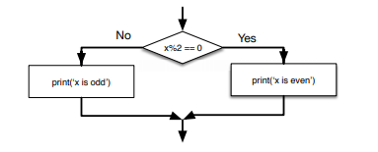

1. Create a program that asks the user how much they purchased. Store this as variable subtotal

Tell the user their total price given the following business requirements:

Shipping is $8

Purchases over $50 or purchases by prime members qualify for free shipping